M.h saboo siddik polytechnic

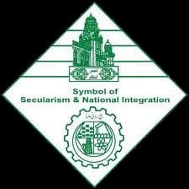

Topic: 3D Isometric model

Branch: Computer Engineering

Guide teacher: Mr. Ziauddin Shaikh sir

Group members:

* 210403- Ansari Midhat
* 210411- Welder Umme Haani
* 210420- Shaikh Mahek
* 210442- Galipelli Rachna

Rationale:

Isometric projection is a type of pictorial projection in which all the three dimensions of the solid are shown in one view. Also their actual sizes can be directly measured from the view.

Isometric drawings are commonly used in technical and engineering drawing to show an item in 3D on a 2D page. Isometric drawings, sometimes called isometric projections, are a good way of showing measurements and components fit together. Unlike perspective drawings, they don’t get smaller as the lines go in distance.

In fact, isometric means having equal dimensions.

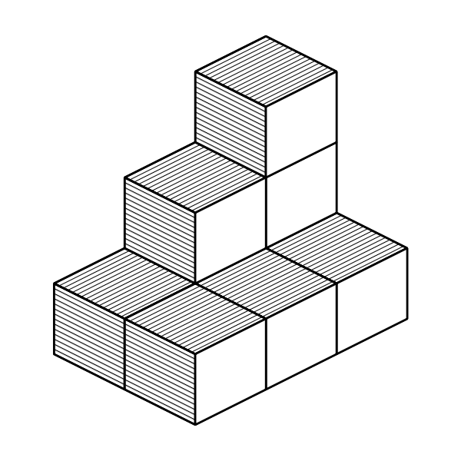

What is an isometric scale?

An isometric scale can be used to draw correct isometric projections.

All distances in this scale are 2/3 or approximately 80% of true size.

3 main rules to isometric drawing:

* Horizontal edges are drawn at 30 degrees.
* Vertical edges are drawn as vertical lines.
* Parallel edges appear as parallel lines.

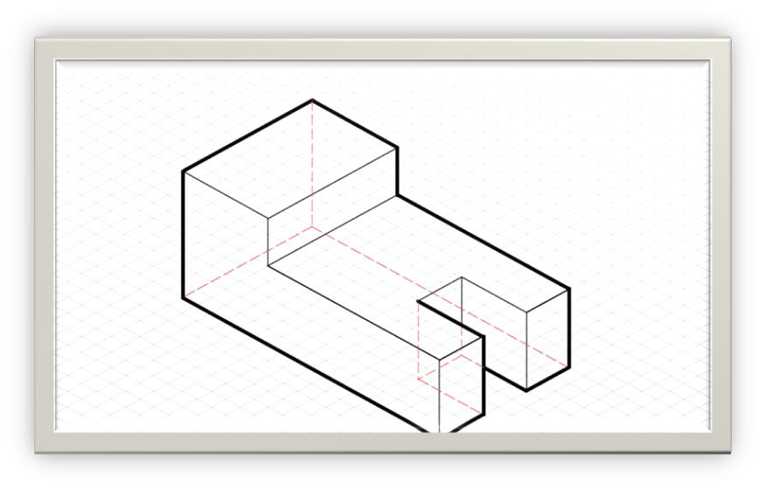

Course outcomes:

1. Draw isometric views of given components from orthographic projection.
2. Draw geometrical figures and engineering curves.

An isometric drawing is nothing but a detailed orthographic drawing that represents the detail of a 3D structure to a 2D structure. In an isometric drawing, the object appears as if it is being viewed from one corner, with the axes being set out from this corner point.

The term “isometric” comes from the Greek for “equal measure” reflecting that the scale along each axis of the projection is the same. An isometric view of an object can be obtained by choosing the viewing directions such that the angles between the projections are all same or 120°

Advantages of isometric:

* It does not need multiple views.
* Illustrates the 3D nature of the object.
* It is easy to layout and measure.

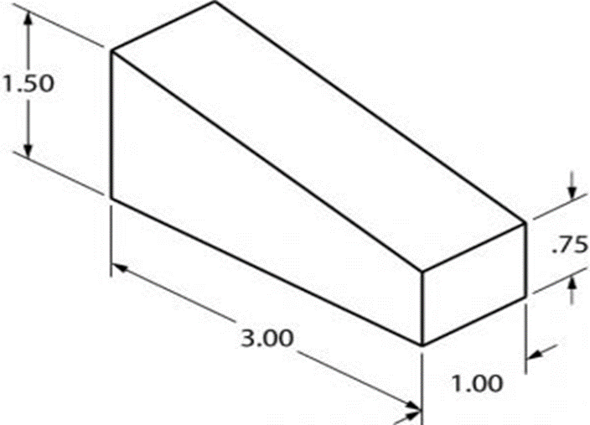

Resources required:

|  |  |
| --- | --- |
| Resources | Quantity |
| * Cardboard | 1 |
| * Colored Paper | 2 |
| * Fevicol | 1 |
| * Scissor | 1 |

Procedure:

The cardboard was given the shape according to the dimensions. It was covered with the colorful paper in order to make attractive. At the end all the cuttings were sticked together and the model was ready.

Outputs of the microproject

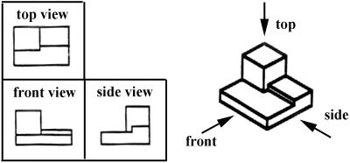

Skills developed:

We learnt to work in groups. We developed the habit of cooperation and there were lots of learnings related to drawing. To draw isometric from orthographic was learnt and from isometric to orthographic was studied. From Unity every task is possible.

Benefits of microproject:

Isometric projection is commonly used by architectures to design the structure of building or houses. It is also important for engineers. In museums and or galleries, an isometric wall maps can show the visitors where they are in building what is going elsewhere, etc.

Illustrator and art director Mauco created an isometric map to represent the areas surrounding the SPECTRUM building in London. It shows the main roads and landmarks to help them orientate themselves. Jing Zhang is an illustrator working mainly with clients in the advertising industry. She’s built a particular reputation for her detailed exploded isometric designs, including the creation for slack.

MS Escher was perhaps the king of using isometric projections in his artworks. His use of parallel geometries to depict mind-bending staircases that go nowhere will be familiar to most.

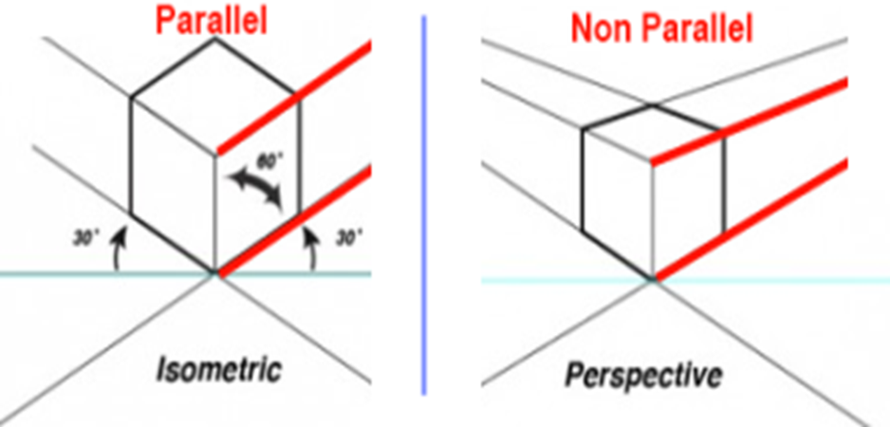

Area of future improvement:

Our skills can improve and isometric models can be made with more discipline and perfection. We will improve our digital skills as well. We will try to make the model with proper dimensions.

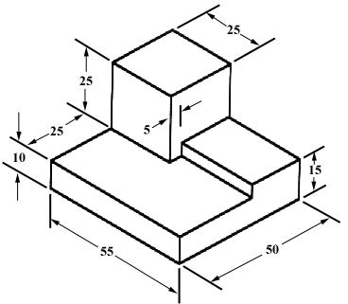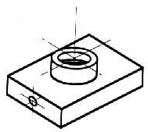

THANK YOU